

**USING GAME THEORY IN**

**MITIGATING COVID SPREAD,**

**AND VACCINATION**

**DSKC Summer Workshop 2021**

**Miranda House, University of Delhi**

By,

Preeti Singh, B.Sc.(H) Mathematics, Semester 4

Priya Rani, B.Sc.(H) Mathematics, Semester 4

Sneha Kumari, B.Sc.(H) Mathematics, Semester 4

Sushmita Kumari Suman, B.Sc.(H) Mathematics, Semester 4

Nidhi Chaudhary, B.Sc.(H) Mathematics, Semester 2

Akshita Bharadwaj, B.Sc.(H) Mathematics, Semester 2

Shreya Kumari, B.Sc.(H) Mathematics, Semester 2

Princy Yadav, B.Sc. Physical Sc. with Computer Sc., Semester 2

**ACKNOWLEDGEMENT**

The presented research paper deals with the topic “Using Game Theory in mitigating Covid Spread, and Vaccination” under the supervision of the Department of Mathematics.

We are immensely grateful to work under DS Kothari Centre summer workshop, 2021.We would like to thank our principal, respected Dr. Bijayalaxmi Nanda for giving us the opportunity to learn and explore the applications of Game Theory. We would like to express our gratitude to our mentors Ms. Apeksha Verma, Dr. Daulti Verma, Mr. Mohit Kumar Macchal and Mr. Mohd. Sarik Idrisi for guiding and helping us in getting a better understanding of the project. We are thankful for their continuous support and valuable information needed to complete our study. It was our pleasure to work in a team and we appreciate every member’s contribution. In the end, we would also like to thank our family and friends for their constant support and encouragement.

**ABSTRACT**

*As the emerging of the recent viable covid-19 prevention strategies and vaccinations, the vaccination uptake and Covid protocols for mitigating the spread of coronavirus have become a key factor in eradicating the virus & building immunity. We have discussed that game theory & social etiquette models should be used to guide decisions pertaining to preventing the transmission of the deadly virus and vaccination programmes for the best possible results. The government has been trying to implement several measures and introduce biological interventions for preventing the transmission but it depends on the people on how to follow it. The decisions taken by individuals as well as in groups affect the spread of the pandemic and the aim is to derive the optimal solution for this problem. In the months after the introduction of vaccines, many countries face scarcity of vaccines. Vaccine hesitancy is also being encountered from some sections of the population. We discussed how the players(individuals) among the population under uncertainty, with only conditionally optimal outcomes can make his/her decision, which is a unique strength of game theoretic modelling. Therefore, we can use this game theory approach to obtain the best framework for modelling & understanding the measures for reducing transmission of coronavirus and vaccination prioritization, and up taking for the optimal control of the Covid-19 pandemic.*

**INTRODUCTION**

**ABOUT THE COVID-19 OUTBREAK**

COVID-19 is a contagious disease caused by severe acute respiratory syndrome- CoronaVirus-2 (SARS-CoV-2). The first case was identified in Wuhan, China in December 2019.

The large spread and increasing number of deaths due to the disease made the World Health Organization (WHO) to declare it as a pandemic on 11 March 2020. The disease has since spread worldwide, leading to an ongoing pandemic. On 1 july 2021, more than 182 million cases were confirmed, with more than 3.95 million people confirmed deaths due to COVID-19, making it one of the deadliest pandemics in history.

The economic and social disruption caused by the pandemic is devastating. About 10 million people are at risk of falling into extreme poverty, while the number of undernourished people, currently estimated at nearly 690 million, could increase by up to 132 million by the end of the year. Millions of enterprises face an existential threat. Nearly half of the world's 3.3 billion global workforce are at risk of losing their livelihood.

Covid symptoms are variable, ranging from mild symptoms to several illnesses. Common symptoms are headache, loss of smell and taste, nasal congestion and runny nose, cough, muscle pain, sore throat, fever and breathing difficulties. The virus spreads primarily through droplets of saliva or discharged from the nose when an infected person coughs or sneezes, so it's important that you also practice respiratory etiquette for example by coughing into a flexed elbow. The best way to mitigate the transmission of the virus is to be well informed about the disease, its underlying causes, modes of transmission, symptoms, etc.

The outbreak affected all segments of the population but is particularly affecting the people living in poverty, older persons, people with disabilities, youth and indigenous peoples.

**THE INDIAN SCENARIO**

In India,the first case was found on 30 January 2020 in Thrissur,Kerala for three individuals who had come from Wuhan. In March, the number of infected people started to increase. Initially,the government imposed preventive measures like thermal screening of passengers arriving at airports, suspending tourist visas and closing educational institutions. Further, on March 24, the government imposed a nationwide lockdown as a major preventive measure to control the spread of COVID-19.

**IMPACT AND VACCINATION**

The COVID-19 recession is an economic recession happening across the world economy in 2020 due to the Covid-19 pandemic. Vaccination is a key tool for controlling this deadly virus and minimizing the global financial burden of Coronavirus disease.

Vaccines and following of guidelines- social distancing, sanitisation et cetera can reduce the risk of infection to exposed individuals that are susceptible to infection and can reduce the probability of transmission from an individual that is infected with Coronavirus.  However, developing a safe and effective vaccine alone won’t be enough to end the pandemic. The vaccine must also be allocated in the most optimum way at an affordable price to the government and distributed in a way that maximises long-term public health impact and simultaneously achieves equity.

This paper uses a game-theoretic approach to develop vaccination strategies for India and construct methods that help to mitigate the spread of coronavirus in India by imposition of lockdowns, following the COVID guidelines, etc.

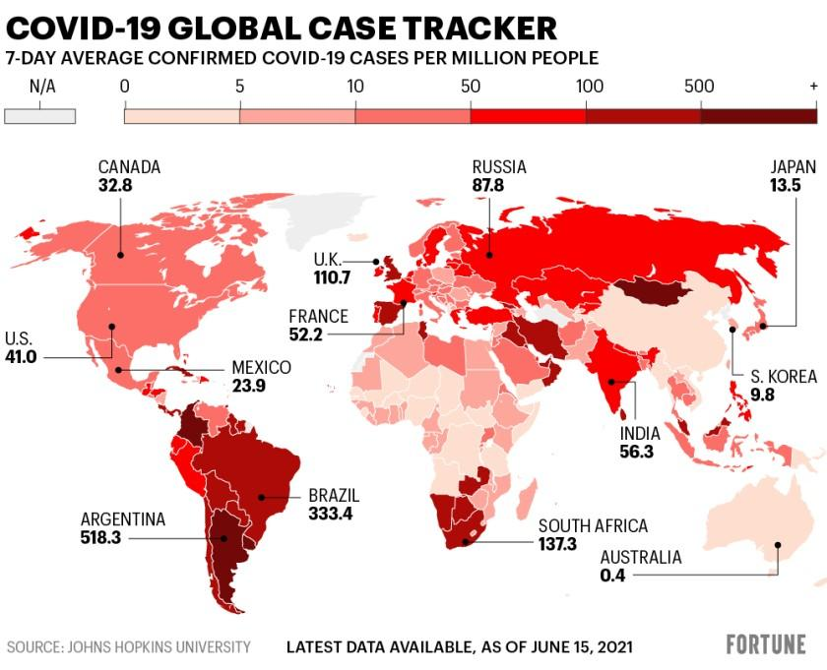

**SIR MODEL OF COVID-19 OUTBREAK:**

The **Susceptible-Infected-Recovered (SIR)** model is a mathematical model used to describe the spread of a disease in a population. In this, the considered population belongs to any one of the three compartment levels: ***Susceptible***, ***Infected*** and ***Recovered***.

*Susceptible (S)* represents the individuals who have no immunity to the disease but they are not infectious, *Infectious (I)* are those who have contracted the disease, and *Recovered (R)* represents the people who have recovered from the disease. Susceptible individuals can move to the next compartment (Infectious) if they interact with infectious beings and get infected. Once recovered from the illness, they can move to the next compartment - Recovered.

Also, it assumes that within the outbreak period, no significant population change takes place and N = S + I + R = constant.

This model was first constructed by **Kermack** and **McKendrick** and can be expressed by the set of time related nonlinear ordinary differential equations:

**𝑑(𝑡)/𝑑𝑡 = − (𝛽𝑆(𝑡)𝐼(𝑡))/N**

**𝑑(𝑡)/𝑑𝑡 = (𝛽𝑆(𝑡)𝐼(𝑡))/N, −𝛾𝐼(𝑡)**

**𝑑𝑅(𝑡)/𝑑𝑡 = 𝛾𝐼(𝑡)**

Notations:

(𝑡): the number of susceptible individuals

(𝑡): the number of infected individuals

(𝑡): the number of recovered individuals

𝑁: the considered constant population size involved in the disease

𝛽: contact rate of the disease

𝛾: mean recovery/removal rate

Initial conditions:

S = 𝑆0

I = I0

R = R0  (at t=0)

Here, we have used the **SIR model** to provide *a mathematical model of the coronavirus outbreak.*

Assumptions involved in the model:

* Within the outbreak period, the population is considered to be unvarying, i.e. N = S + I + R = constant.
* Secondary waves of infections and any other outbreaks of the infection are not considered.
* All the infected beings have the same probability of being recovered.
* The real time data of the officially reported positive cases are used for the model.

Solving the equations we get,

**(𝑡) = S0 e− 𝛽/𝑁𝛾(𝑅(𝑡)−𝑅0)**

We can use this differential equation for knowing the extent of the outbreak, recovery rate, etc.

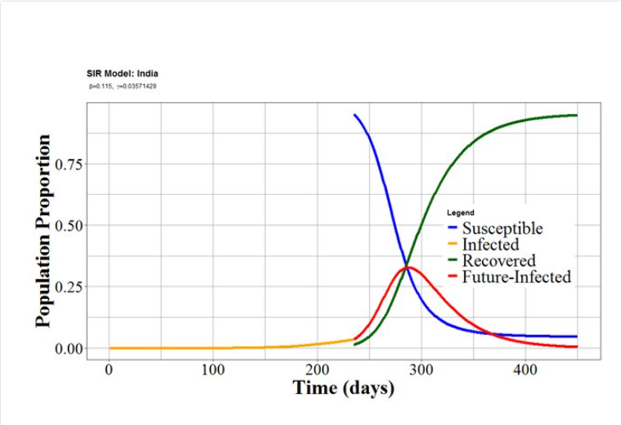

Fig: SIR model of COVID-19 pandemic in India, representing the Susceptible, Infected, and Recovered cases as a function of the number of days since 22 January 2020. The model shows a peak around 290 days (06November 2020) and complete recovery after four hundred and fifty days from 22 January 2020.

**OBJECTIVE**

This paper aims to find optimal strategies for mitigating the spread of coronavirus in India and vaccinating people. We have used a game theoretic approach in dealing with the scenario. The study consists of finding the best way of implementation of lockdown, optimal condition of compliance of individuals with the guidelines and interventions pertaining to Covid-19, and then it moves on to the vaccination game. Game Theory is used to find how individuals should make decisions pertaining to vaccination taking into account the vaccine hesitancy in India, and developing strategies relating to which age groups should be vaccinated first in order to result in a fall in death rate of people due to Covid-19.

**METHODOLOGY**

**GAME THEORY:**

Game Theory is the study of strategically interdependent behaviour i.e., what one player does affect the other player outcomes & vice versa on the basis of the set rules & includes pay-offs such as win, lose or draw. Game Theory in the form known to economists, social scientists & biologists, was given its first general mathematical formulation by John Von Neumann and Oskar Morgenstern in 1944.

The word “*game*” is appropriate to describe this because, just as in common parlour games such as Chess or Hex, much of game theory is concerned with how individuals (persons, or organizations) choose actions, considering how other participants do. It is concerned with specifying actions for all players, ensuring that for each player, his/her chosen actions are optimal.

***A game in normal form consists of:***

1. A (finite) number of players M = {a1, . . ., an}
2. A strategy set Si assigned to each player i∈ M. The combination of all sets of strategies S = Пi∈ M Si is called strategy space.
3. A payoff function ui: S→ R, assigned to each player i∈ M. ⇒∀s ∈ S: ui(s) ∈ R

**Visual Layouts:**

There are mainly two ways of visualizing games in game theory: ***Matrices*** & ***Trees***.

**Matrices:**

Payoff matrix is a basic tool used in game theory. Generally, they are used to describe 2-player, simultaneous games. They show the expected payoff for each player assuming they took that action.

**Trees:**

A game tree is a directed graph with nodes & edges. Nodes represent player positions or payoffs. Nodes represent the array choices for a single player at a single point in time**.** Edges represent the moves, or actions, taken by the player/node.

**TERMINOLOGIES:**

|  |  |  |
| --- | --- | --- |
| **1.** | ***Game*** | Any interaction between two or more players in which each player’s payoff is affected by their decisions and decisions made by others. |
| **2.** | ***Players*** | A strategic decision-maker within the context of the game. |
| **3.** | ***Actions*** | The strictly-defined behaviours that a player has to choose to perform. |
| **4.** | ***Strategy*** | A plan of action a player will take given the situations that might arise within the game. |
| **5.** | ***Payoff*** | The payout a player receives from arriving at a particular outcome (it can be in any quantifiable form, from dollars to utility). |
| **6.** | ***Saddle Point*** | The element in a payoff matrix that is the smallest in a particular row while, at the same time, the largest in its column. |
| **7.** | ***Information set*** | The information available at a given point in the game. |
| **8.** | ***Value System*** | Abstract & context-dependent, this is the range of all possible values; anything from jail-time, to market share, to land occupation. |
| **9.** | ***Value of Game*** | It refers to the expected outcome per play, when players follow their optimal strategy. |
| **10.** | ***Equilibrium*** | The point in a game where both players have made their decisions and an outcome is obtained. |

**EXAMPLE-The Prisoner’s Dilemma:**

The prisoner’s dilemma is a scenario in which the payoff from cooperation is larger than considering and pursuing self-interest. It’s name was first coined by Canadian mathematician Albert W. Tucker in 1950.

***Scenario:***

* Two suspects are arrested (let the name be Mike & Steve)
* The police think that they were trying to rob a store but the cops can only prove that the suspects were trespassing.
* Thus, the police need one of the criminals to rat out the other. Each of the suspect is privately interrogated and a deal is being to them

***The potential deal:***

* If no one confesses to robbery, then the police can only charge both of them with trespassing with a punishment of 1 month jail each.
* If one confesses and the other doesn’t,then the police will be lenient on the rat, giving 0 months of punishment & severely punishing the quiet one with 12 months of punishment.
* If both confess, the police punish both of them. Punishment: 8 months in jail each.

***The Payoff Matrix:***

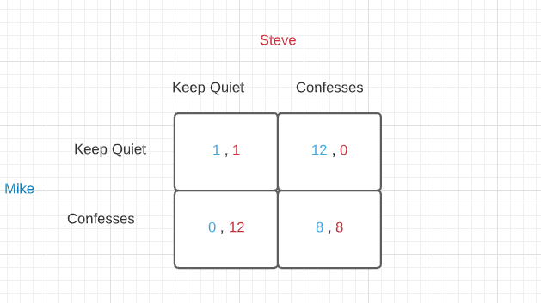

The dilemma is that their own ‘pay-off’ is wholly dependent on the behaviour of the other prisoner.

**Types of Strategy:**



**Maximax:** A *maximax* strategy is one where the player attempts to earn the maximum possible benefit available. This means they will prefer the alternative which includes the chance of achieving the best possible outcome – even if a highly unfavourable outcome is possible.

The best pay-off for Mike from confessing is 0 months (with Steve keeping quiet), and the best pay-off from keeping quiet is 1 month (with Steve keeping quiet) – so the **best of the best** is to confess.

**Maximin:** A *maximin* strategy is where a player chooses the *best of the worst* pay-off. This is commonly chosen when a player cannot rely on the other party to keep any agreement that has been made.

For example, to keep quiet in the Prisoner’s Dilemma, the worst pay-off to mike from confessing is to get 8 months (with Steve confessing), and the worst pay-off from keeping quiet is 12 months (with Steve confessing) – therefore the **best of the worst** is to confess.

In this case, both the maximin and maximax strategies would be to confess. When this occurs, it is said to be the dominant strategy.

**Minimax:** In game theory, *minimax* is a decision rule used to minimize the worst-case potential loss; in other words, a player considers all of the best opponent responses to his strategies, and selects the strategy such that the opponent's best strategy gives a payoff as large as possible.

For Example, the best pay-off for Mike from confessing is 0 months (with Steve keeping quiet), and the best pay-off from keeping quiet is 1 month (with Steve keeping quiet) – so the **worst the worst** for both is to not confess.

**Dominant strategy:** A dominant strategy is the best outcome irrespective of what the other player chooses, in this case it is for each player to confess – both maximax and maximin result in the same decision being taken.

**Types of Games:**



Fig: Flow Chart showing types of Games

There are different types of games that are being used in Game Theory to solve different types of problems. These games are formed on the basis of number of players and their cooperation in the game and symmetry of the game.

Different types of Games in game theory are explained below:

1. ***Cooperative and Non-Cooperative games***

In Cooperative games, the players are convinced to adopt a particular strategy through negotiations and agreements among them.

One example of Cooperative games can be that of liquor organisations. Here the dilemma is that they have high ad expenditures that they want to reduce and they are not sure whether the organisation would follow them or not. However, when the government restricts the advertisement of liquor on the television this would help in reducing the ad expenditure of liquor organisations.

Non-Cooperative games include those in which players decide their own strategy to maximize their profit. Prisoner's dilemma can be an example of a non-cooperative game.

1. ***Normal form and Extensive form games***

In normal form games the payoff and strategies of a game are represented in a tabular form hence termed as normal form games. It helps in identifying the dominated Strategies and Nash equilibrium. The Matrix shows the strategies of different players and their possible outcomes.

In extensive form games the description of the game is done in the form of a decision tree. It helps in the representation of events that may occur by chance. It is a tree-like structure in which the names of players are located on different nodes and also in this structure the payoff and feasible actions of each player are also given.

1. ***Simultaneous move games and Sequential move games***

Simultaneous move games are those in which the strategies adopted by the two players is Simultaneous. In this game the players don't know about the strategies of other players.

On other hand, Sequential move games are those in which players are aware about the strategies of players who have already adopted a strategy. However, in sequential move games players do not have exact knowledge of the strategies of other players. Simultaneous games are presented in normal form and sequential games are presented in extensive form.

1. ***Constant Sum, Zero Sum, and Non-Zero-Sum games***

In Constant sum games the sum of outcomes of all the players remains constant even if the outcomes are different. Zero Sum games are a kind of constant Sum game in which the sum of outcomes of all players is zero. In zero Sum game strategies of different players don't affect the available resources. Also, the gain of one player is always equal to the loss of the other.

Whereas in non-zero-sum games the sum of outcomes of all players is not zero however a non-zero-sum game can be transformed to zero sum game by adding a dummy player. Here the losses of dummy players will be overridden by the net earnings of players.

Examples of zero-sum games include chess, gambling , etc in which the gain of one player results in the loss of another. Cooperative games are examples of non-zero-sum games because either every player wins or loses in a Cooperative game.

1. ***Symmetric and Asymmetric games***

Symmetric games are those in which strategies adopted by all players are the same. The decision in a symmetric game depends on the strategies used, not on the players of the game. Even in case of interchanging players the decision remains the same. Prisoner's dilemma is an example of Symmetric games.

Asymmetric games are those in which strategies adopted by the players are different. In asymmetric games, it's not necessary that the strategy that provides benefit to one player will be equally beneficial to another. However, the decision making depends on the different types of Strategies and decisions of players.

Example of an asymmetric game can be the entry of a new organisation in a market because different organisations adopted different strategies to enter in the same market.

**NASH EQUILIBRIUM:**

Nash equilibrium, the term named after John Nash, is a solution to a game where players want the best outcome for themselves & must take the actions of others into account.

When Nash is reached, then an individual player cannot change its strategy independently i.e. it is the best strategy to what others have chosen & will not change it.

It is a set of strategies, one for each player, such that no player has incentive to change his or her strategy. We only care about individual patients, not group deviation. They are indignantly stable - what you are doing is optional giving what I am doing and vice versa.

think about traffic

In some situations, following stop lights is a Nash equilibrium.

Suppose two cars are driving at each other from perpendicular distance

the stop light is red for one of them and green for the other if police could not ticket the drivers will they want to break the law?

|  |  |  |  |
| --- | --- | --- | --- |
|  | Go | Stop |  |
| Go | -5, -5 | 1,0 | ←Nash equilibrium |
| Stop | 0,1 | -1, -1 |  |
|  | ↑  Nash equilibrium |  |  |

A Player never chooses a strictly dominated strategy. We define a strictly dominated strategy as a strategy that pays less regret less of what the other player does here in prisoner's dilemma defects dominant corporate.

|  |  |  |  |
| --- | --- | --- | --- |
|  | Left | Centre | Right |
| Up | 13,3 | 1,4 | 7,3 |
| Middle | 4,1 | 3,3 | 6,2 |
| Down | -1,9 | 2,8 | 8,-1 |

How can we solve this 3 x 3 matrix complicated game? One of the ways is to search for strictly dominated strategies.

Take a look at Santa and right for player to we should not assess Centre strategy dominates right

              4>3

              3>2

 8>-1

thus, we can say that maths Centre strategy dominates write the neat thing is when you know the piece of information, we can convert the nation from figure 1 to the figure 2

|  |  |  |
| --- | --- | --- |
|  | Left | Centre |
| Up | 13,3 | 1,4 |
| Middle | 4,1 | 3,3 |
| Down | -1,9 | 2,8 |

Basically, we are meant that we can ignore the right for all intents and purposes and threat this 3 x 2 Matrix as legitimate representation of the previous game and now we noticed that middle now dominates down for player one as

4>-1

3>2

We have an interesting thing as if we see about light then the above case is not there as 6<8 but because the rules of strictly dominated strategies allow us to eliminate and their strategies from the Game and we rewrite Matrix as figure to now we can say that middle dominates down and get of down giving us with the game.

|  |  |  |
| --- | --- | --- |
|  | Left | Centre |
| Up | 13,3 | 1,4 |
| Middle | 4,1 | 3,3 |

Now we can know that Centre strictly dominates left for player to as

4>3

3>1

Which wasn't the case again just before because 8<9

But we can eliminate this mercilessly due to the rules of strictly dominated strategies leaving us with this game remaining in figure 3 and for our last iterated elimination.

|  |  |
| --- | --- |
|  | Centre |
| Up | 1,4 |
| Middle | 3,3 |

The seed at middle is strictly better than up for the remaining game so player one will play middle and that gives us our unique equilibrium middle centre.

In the COVID-19 vaccine rollout, the “players” would be individuals seeking care; the actions would be the individuals' selection of a facility; and the payoffs would be measured in terms of how individuals perceive the risk of vaccination, distance travelled, and level of service available at a chosen facility. The level of service might be captured in terms of the congestion of facilities or a supply-demand ratio.

**FINDING OPTIMAL STRATEGY TO MITIGATE CORONAVIRUS SPREAD IN INDIA**

The spread of COVID-19 has forced citizens around the world to take in account & reconsider the high social & economic costs of epidemic control. According to WHO, behavioural changes at the community level such as following *stay-in-home orders, maintaining social distancing, & vaccines,* are a major effective tool against any of the infectious diseases.

Understanding people as players in a game, each player having their own strategy, we will study the payoff of their strategy, each strategy having a significant impact at a community level in combating COVID-19.

**IMPLEMENTATION OF LOCKDOWN:**

Here, we have to determine the economic decision which people and government should take to reduce the transmission of SARS-CoV-2 and achieve an optimal condition.

For this work, lockdown is an important measure being taken to reduce the transmission and fatality rate. An individual can choose to comply with the lockdown and the government can decide whether it wants to impose the lockdown or not. The analysis of the dynamics of the players is done using the diagrammatic approach and the conclusions are arrived at separately for the mentioned scenarios.

Assumptions:

1. There are two players in this game – Government and Public.

2. The ‘Government’ has two strategies in its hand – adopting the lockdown or withdrawing it.

3. The ‘Public’ has two strategies in its hand – accepting the lockdown or rejecting them.

4. Both players are rationale.

5. Governments choose the strategy which maximises public utility.

6. Public tries to maximize individual private utility.

7. Same information is available to everyone – the virus will spread more through human contact and mobility.

8. People affected by viruses would afford their own costs of treatment

Pay-off matrix for the game:

|  |  |  |
| --- | --- | --- |
|  | ADOPTING THE LOCKDOWN  (Government) | REJECTING THE LOCKDOWN  (Government) |
| ACCEPTING THE LOCKDOWN  (Public) | 1 All are safe  Safe and no spread | Safe for all and low 2  marginal cost  Individual safe and no spread |
| REJECTING THE LOCKDOWN  (Public) | Difficulty to control cost  3  Virus attack and spread | Increase of virus  4  Virus attack and mass spread |

Above mentioned payoff matrix shows the result of the game played between the public and government.

**Box 1** expresses the condition that when the government adopts the lockdown and the public obeys the lockdown and rules then the government will get pay off of all safety which can reduce the social marginal cost of pandemic and the financial resources.

**Box 2** shows the condition when the government withdraws the lockdown rules but the public still follows most of it and takes precautions in daily life. Then the situation will be safe for the individuals as well as safe for all and will result in low marginal social cost.

**Box 3** shows the payoff for the Government and public while the government uses the strategy of lockdown but the public rejects it. In that case, most of the covid-19 rules get violated and virus spread becomes faster. This case is definitely not an efficient solution for both individual and social areas.

**Box 4** shows the condition when the government withdraws the lockdown and also the public are not following any lockdown regulations assuming that the pandemic is solved. In this case both the players Government and public are equally responsible for the widespread of virus and increasing the marginal social cost.

*The condition in* ***Box 2*** *is quite desirable for both players and* ***is the optimal solution of the game.***

**INDIVIDUAL OPTIMAL CHOICES:**

Here, “intervention” is defined as being a public health measure that mitigates the transmission of Covid. There are non-pharmaceutical interventions, such as masks, or biomedical interventions, such as a vaccine. A binary choice is defined as the compliance with an intervention. An individual can choose to either comply or not comply with an intervention based on the perceived costs and benefits of the intervention.

Using a game theoretic framework, we have modelled this choice which compares the perceived cost of compliance in relation to perceived cost of infection to the individual. Individuals get a benefit or cost (i.e., a payoff) by interacting with other individuals in the population, who can either be compliers or non-compliers. We have to determine the conditions under which noncompliance will maximize the costs.

For this two-strategy “game”, the payoffs to compliers and non compliers are given in the following Table.

Payoff matrix for compliers / non-compliers:

|  |  |  |
| --- | --- | --- |
|  | Non-compliant  interaction  partner | Compliant  interaction  partner |
| Non-complier  payoff | -αu mu | -αv mu c |
| Complier payoff | -q-αu mv b | -q-αv mv b c |

Here, q: cost of intervention

          αi: fraction of infected individuals of type I,

          mi: perceived cost of infection for type I,

           i: either u (non-compliers) or v (compliers),

           b: efficacy of intervention in protecting the individual from getting infected,

           c: efficacy in preventing transmission.

Non-compliance is a Nash equilibrium if,

**I.                 -αu mu> -q-αu mv b**

**II.               -αv mu> -q-αv mv b**

            Or equivalently,

**I.     αu < q / (mu-mv b)**

**II.    c αv < q/ (mu-mv b)**

Since, non-compliers are much more likely to be infected than compliers.

Implies that, αu> c αu

Therefore, meeting the condition (I) alone

i.e., non-compliers receive a greater payoff than compliers when interest with both non-compliers is sufficient for noncompliance to be a Nash equilibrium.

*The expected payoff to non-complies is greater than the payoff to compliers. Hence, the cost will be more for non compilers than compliers.*

**THE VACCINATION GAME**

The vaccines used by India are- the Oxford-AstraZeneca jab, also known as Covishield, Covaxin by Bharat Biotech, and Russian-made Sputnik V.

The government has also authorised Indian pharma company Cipla to import Moderna's vaccine, which has shown nearly 95% efficacy against Covid-19. But it's not clear yet how many doses will be made available to India.

Several more vaccines are in various stages of approval.

Vaccination is voluntary. State-run clinics and hospitals are offering free jabs, but people can also pay 250 rupees ($3.4; £2.4) for a dose at private facilities.

The government is spending around $5bn to provide free doses at state-run clinics, public health centres and hospitals.

But doctors say that a third wave is inevitable given that the country has fully reopened even as the threat of new variants looms large.

The drop in the average number of daily vaccine doses is also worrying experts.

And there is a gender gap - government data shows 14% fewer women are getting vaccinated. This is especially true in rural India where women have limited access to the internet and are hesitant or scared to take the vaccine.

Although a higher number of doses are being administered daily in rural areas, the share of population being vaccinated in urban areas is still greater. Equitable access to safe and effective vaccines is critical to ending the COVID-19 pandemic, so it is hugely encouraging to see so many vaccines proving and going into development.

**VACCINE HESITANCY:**

Vaccines, or getting vaccinated, are one of the most effective solutions in eradicating the pandemic. But there are factors such as vaccine hesitancy among the population, or who to be vaccinated first, which lead to different strategies of an individual player and hence a different payoff to him/her. Players are weighing themselves between getting jabbed with their individual strategy & the morbidity risks of vaccine infection in view of the transmission risk of the disease in the community at a particular given time.

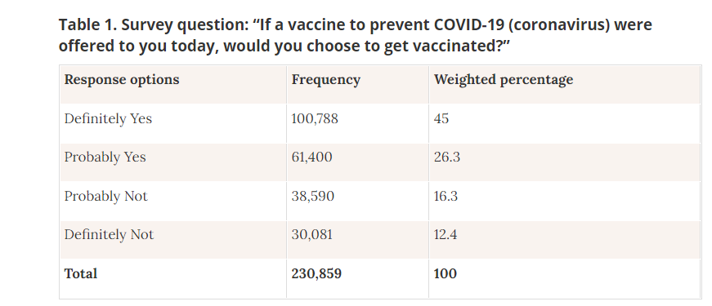

Statistics of a survey taken to know about vaccine hesitancy among people in India

Source: COVID-19 Symptom Survey

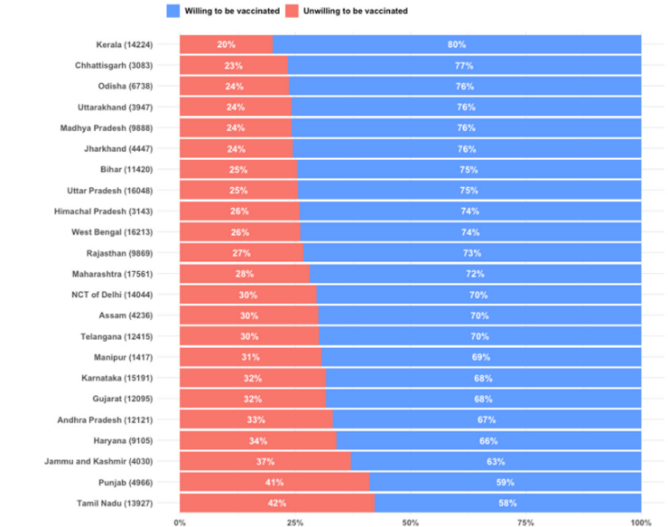

Statistics showing state-wise vaccine hesitancy in India

Source: COVID-19 Symptom Survey

Here, we will describe the individual strategy of getting vaccinated with a Game Theoretic approach.

***Description of Game:***

All the players are provided with the same information & access this same information in considering the risks.

Let a player’s strategy is the probability P that he/she will choose to vaccinate. The vaccine uptake level in the population is the proportion of all the eligible players who will be vaccinated & hence is the mean of all the strategies adopted by players in the population.

We are assuming that there will be no change in vaccine uptake & corresponding changes in overall vaccine coverage in the population, & consequently if no infection-related or vaccine-related mortality occurs, then proportion of players vaccinated, p, will be equal to vaccine uptake level.



The payoff to a player will be greater if the morbidity risk will be lower.

NOTATIONS:

               rᵥ = morbidity risks from vaccination

               rᵢ = morbidity risks from infection

              ℼₚ = probability that an unvaccinated player will eventually be infected if vaccine coverage level is ‘p’ in the population

Payoff to vaccinated player = - rᵥ

Payoff to unvaccinated player = - rᵢ ℼₚ

Thus, strategy of vaccinating with probability P yield expected payoff

**E (P, p) = P (- rᵥ) + (1 - P) (- rᵢ ℼₚ)**

***Characterization of Nash Equilibrium:***

As we have earlier let a player’s strategy of probability P, but some other player follow different strategies, e.g., many are like ‘wait & see type’ in getting vaccinated & hence, they are prone to the infection & thus, have a lower payoff than P. Let the other strategy be Q.

Hence, P will always give a higher payoff than Q.P is said to be a *Nash equilibrium.*

In contrast, if most of the players adopt strategy Q, but the players adopting a strategy which is closer than Q to P, obtain a higher payoff than those adopting Q (and also from those adopting strategies further from P obtain a lower payoff), & if it is for any Q ≠ P, then P is said to be convergently stable.

* If P is a Nash equilibrium, & every player currently playing P, then no one should change strategy.
* If P is convergently stable, then no matter which strategy is most common, one should start to play strategies closer to P, & ultimately adopt P.

A general expectation is that a strategy observed in a real population must be a convergently stable Nash Equilibrium (CSNE).

Let us suppose that a proportion ε of the population vaccinates with probability *P* and the remainder vaccinates with probability *Q*. Because we ignore any difference between vaccine uptake and overall vaccine coverage in the population, so we can write

**p = ℇP + (1-ℇ)Q**

The payoff to individuals playing *P* is, therefore,

**Eₚ(P,Q, ℇ) = E(P, ℇP + (1-ℇ)Q)**

whereas the payoff to individuals playing *Q* is

**Eq(P,Q, ℇ) = E(Q, ℇP + (1-ℇ)Q)**

The payoff gain to an individual playing *P* in such a population is

**∆E= EP-EQ=[πℇP+(1-ℇ)Q – r](P-Q)**

The payoff gain Δ*E* is a measure of the incentive for an individual to change strategies from *Q* to *P*.

For any given relative risk - *r*,

there is a unique strategy *P* = *P\**, such that Δ*E* is strictly positive for all strategies *Q* ≠ *P*\* and all proportions ε, where 0 ≤ ε < 1

The special case of the above fact for small proportions playing *Q* (ε near 1) implies that *P*\* is a Nash equilibrium.

But if neither *P* nor *Q* is equal to the Nash equilibrium *P*\*, but *P* is closer than *Q* to *P*\*,

then Δ*E*> 0,

implying that *P*\* is convergently stable and hence a CSNE.

The unique CSNE in this vaccination game is easily found.

*If the vaccine is perceived to be sufficiently risky (r ≥ π0) then the CSNE is “never vaccinate” (P* = 0). In contrast, if r < π0, then the CSNE is “vaccinate with nonzero probability P*” (0 <P*< 1). In the latter case, the CSNE is said to be mixed (as opposed to the pure strategies P = 0 and P = 1).*

**VACCINATION ON THE BASIS OF AGE GROUP:**

#### Since there is a limited availability of vaccines at the initial stages, it is crucial to have effective prioritization and optimal use of the resources. If the vaccine reduces the transmissibility of the coronavirus, prioritization should be based on targeting individuals, or regions that can act as critical nodes of transmission or massive spreaders. Whereas if the vaccine reduces symptoms or mortality, prioritization should be based on targeting individuals, or regions that will have poor outcomes if infected.

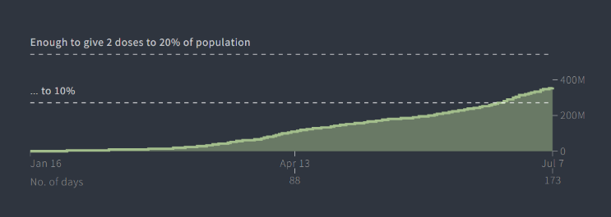

Fig: Statistics of vaccine doses in India

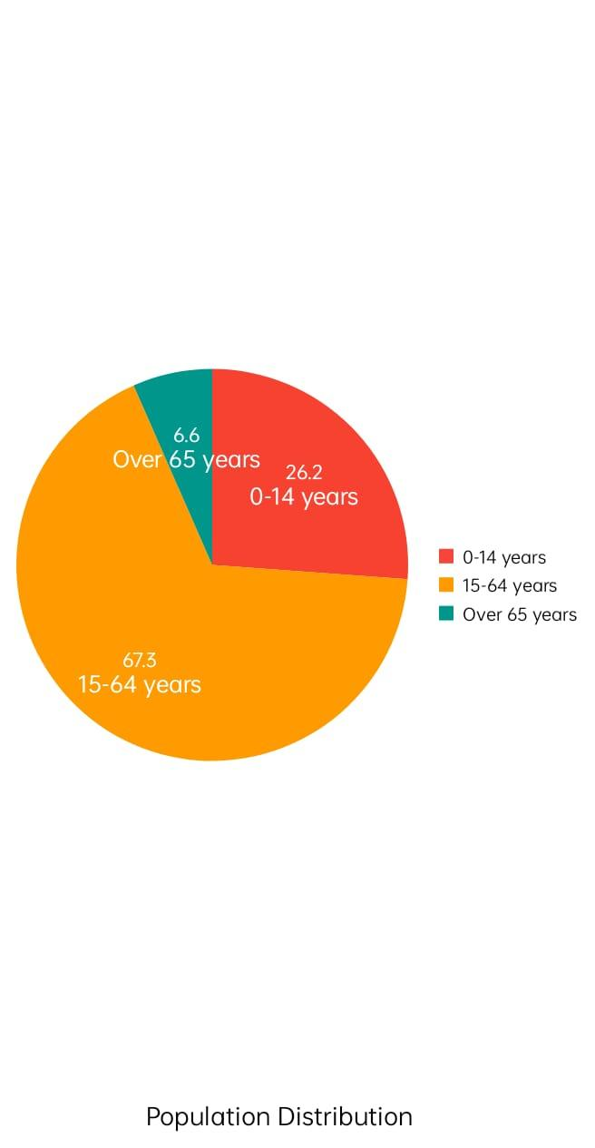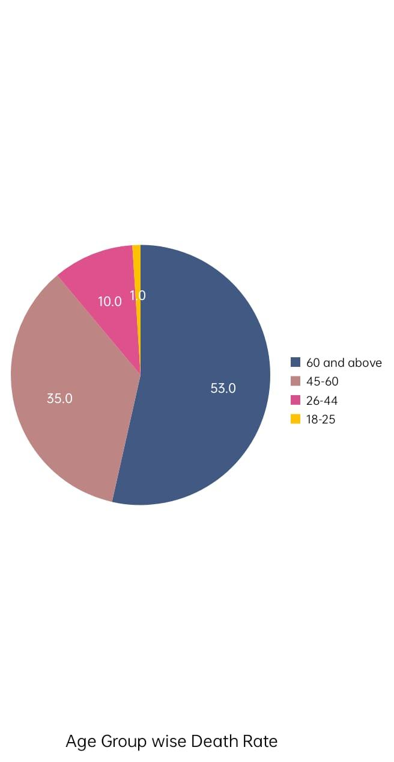

Currently the population of India is around 136.64 crores. Out of which 26.16% of the population consists of the age group 8 to 14 years. 67.27% consists of the age group 15 to 64 years and there are 6.57 percent of the population that falls under the age group of 65 years or above.

According to the report, about 53% of the victims who died due to covid aged 60 years and above and also some fraction of elderly people with comorbidities. This data clearly shows that the young people and those above 60 years with comorbidities should be in the priority group for the vaccination.

**Reasons:**

1.People with comorbidities have less immunity prior to the viral infection due to other diseases so they are more likely to be susceptible to infection and less likely to survive.

2. Although only 45% of the young people in the 26 to 60 age group have succumbed to the infection. They constitute a major part of the total population and hence are more likely to increase the infection rate even exponentially if their socialization is minimised and also, they are equally responsible for the country's herd immunity as well.

|  |  |  |
| --- | --- | --- |
|  | If young people  are vaccinated | If young people are not vaccinated |
| If old people  are vaccinated | 2               5 | 2               0 |
| If old people are not vaccinated | 0                5 | 0              0 |

**CONCLUSION**

Comprehensively, the study shows that to mitigate the spread of COVID-19, it is imperative to follow certain guidelines and have effective vaccination strategies. With respect to implementation of lockdown, the optimum strategy is when the government has to spend the least amount on implementing the strategy but the public still follows the proper measure resulting in mitigating the transmission of the virus in the most effective way. Moreover, individuals should follow up to the interventions- masks, sanitisation, et cetera to minimise costs. In relation to vaccination, it is crucial that people overcome vaccine hesitancy, and for the government it is important to vaccinate the people above age group 60 so that the death toll decreases.

**REFERENCES**

* <https://www.pnas.org/content/101/36/13391>
* <https://journals.plos.org/plosone/article?id=10.1371/journal.pone.0232652>
* <https://royalsocietypublishing.org/doi/10.1098/rsos.201095>
* <https://marcellus.in/story/the-pandemic-is-a-prisoners-dilemma-game/>
* <https://www.google.com/url?sa=t&source=web&rct=j&url=https://www.jstor.org/stable/23443875&ved=2ahUKEwi8u8ar_bfxAhWSF3IKHTaTAcoQFjABegQIBBAC&usg=AOvVaw2jjrpB0eMyIMc0ZDnpyHIk&cshid=1624802642704>
* <https://graphics.reuters.com/world-coronavirus-tracker-and-maps/countries-and-territories/india/>
* <https://www.statista.com/topics/6135/coronavirus-covid-19-outbreak-in-india/>
* <https://bmcpublichealth.biomedcentral.com/articles/10.1186/s12889-021-10829-2>
* <https://www.economicsonline.co.uk/Business_economics/Prisoners_dilemma.html>
* <https://en.wikipedia.org/wiki/Nash_equilibrium>
* <https://royalsocietypublishing.org/doi/full/10.1098/rsos.210429>
* <https://amp.scroll.in/article/994817/covid-19-deaths-are-declining-among-the-elderly-does-it-mean-that-the-vaccine-effect-is-kicking-in>
* <https://www.researchgate.net/publication/341718481_Mathematical_Modelling_of_Coronavirus_disease_COVID-19_Outbreak_in_India_using_Logistic_Growth_and_SIR_Models>
* <https://royalsocietypublishing.org/doi/full/10.1098/rsos.210429>
* <https://www.medrxiv.org/content/10.1101/2020.05.14.20101725v1>
* <https://www.economicsdiscussion.net/game-theory/5-types-of-games-in-game-theory-with-diagram/3827>
* <https://www.theorie.physik.uni-muenchen.de/lsfrey/teaching/archiv/sose_06/softmatter/talks/Heiko_Hotz-Spieltheorie-Handout.pdf>
* <https://towardsdatascience.com/the-basics-of-game-theory-db1964520cbe>
* <https://www.investopedia.com/terms/g/gametheory.asp>
* <https://www.sciencedirect.com/topics/neuroscience/game-theory>
* [https://www.who.int/news/item/13-10-2020-impact-of-covid-19-on-people’s-livelihoods-their-health-and-our-food-systems#:~:text=The%20COVID%2D19%20pandemic%20has,and%20the%20world%20of%20work.&text=Nearly%20half%20of%20the%20world’s,risk%20of%20losing%20their%20livelihoods](https://www.who.int/news/item/13-10-2020-impact-of-covid-19-on-people%E2%80%99s-livelihoods-their-health-and-our-food-systems#:~:text=The%20COVID%2D19%20pandemic%20has,and%20the%20world%20of%20work.&text=Nearly%20half%20of%20the%20world%E2%80%99s,risk%20of%20losing%20their%20livelihoods)
* <https://www.un.org/development/desa/dspd/everyone-included-covid-19.html>
* https://www.bbc.com/news/world-asia-india-55748124